Procedure for Remote Support
- Please stop sending requests for programming help via email, we need a more efficient way of providing support.
- Requests for other support and information are fine by email.
- Before you contact your tutor check the discussion board now available on BB to see if your question has already been answered.
Discussion board available here…
https://vle.dmu.ac.uk/webapps/blackboard/content/listContentEditable.jsp?content_id=_4591450_1&course_id=_550815_1&mode=reset
- If there is no solution there, then post your question to the discussion board and patiently await a reply.
- If it is not possible to solve the problem via the discussion board then contact your tutor directly to arrange a virtual meeting.

Matthew– use the booking system on the web site
Dawn– email
Salimah– email
Peter– email

- In advance of any meeting make sure you proved the following details by email
  - Azure Credentials, server, database name, username and password
  - The name of your section (staff/customer etc.)
  - Make sure that your database owner has added your tutor to the firewall rules for your server
Dawn
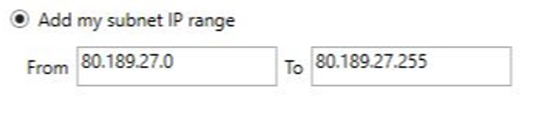
Salimah
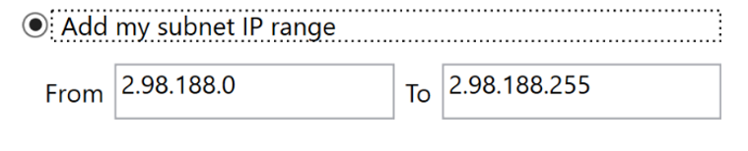
Matthew
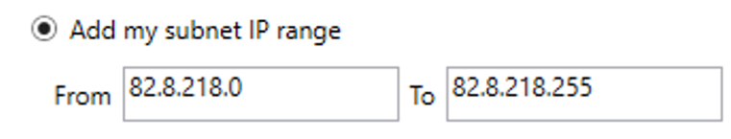
Peter
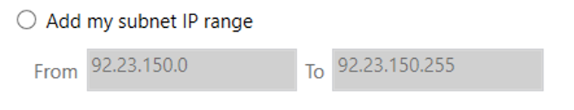
  - Zip up your work make sure the zip file is named with your full name and P number, e.g.


  - Upload your work to the OneDrive folder for your tutor

Dawn
https://demontfortuniversity-my.sharepoint.com/:f:/g/personal/djohns02_dmu_ac_uk/EvLmyyjaw01PpBGLCgnhiyEBUxQB9oWxpq3n4daw1x-CRg?e=zEtiyM

Matthew
https://demontfortuniversity-my.sharepoint.com/:f:/g/personal/mdean00_dmu_ac_uk/EkOWJXOQb-ZDmmOAjBAz-eEBDEjZaSxEHJExotFs4jK4HQ?e=MgJ16Q

Peter
https://demontfortuniversity-my.sharepoint.com/:f:/g/personal/plmb_dmu_ac_uk/EmounnPetM5DnB-imGqh2AUBMdZDT2dEe6Nu2ohWExdR0g?e=39K5Wf

Salimah
https://demontfortuniversity-my.sharepoint.com/:f:/g/personal/smoham04_dmu_ac_uk/EkfAuzQomoNKjcCsAMMxC4IBDSRcl2NdX-FvlBiKoIVgUA?e=tePyuZ

  - Respect that you may see work belonging to other students in the shared folder – if it doesn’t have your name on it please leave it alone

  - Attend the virtual meeting, if you cannot attend please let your tutor know, please try not to be late as other students need help too!

  - When you collect your work after the meeting please delete it off the OneDrive link, again please take care not to interfere with work belonging to others

